Profit & Loss Statement - Financial Analysis Using MS Excel DAX

Aim
Built to analyze multi-year P&L performance across geographies for management reporting.

What is in Excel
This Excel shows a Profit & Loss Statement created using MS Excel. It shows Profit and Loss Statement and calculations of Total Sales, Gross Profit, EBITDA, Operating Profit, PBIT, and Net Profit per year, per quarter and per country (slicer).
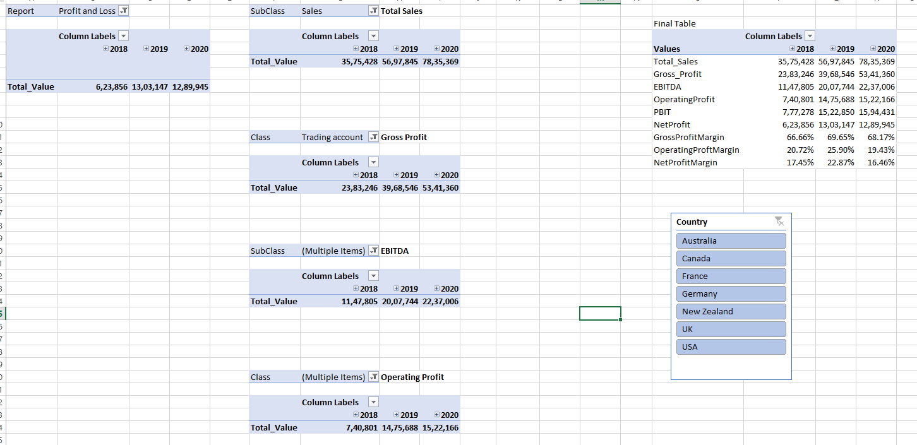

Calculations Used
Calculation | DAX Formula Used | Screenshots  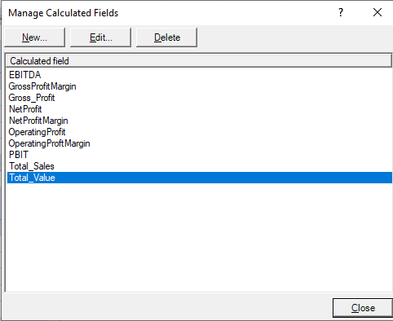 | Filters Used | General Filters/Slicers
Total_Value | =SUM(tbl_GL[Amount]) | 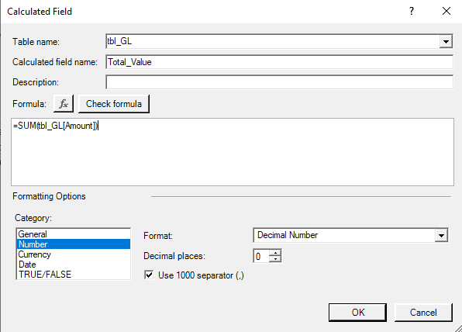 | None | Quarter, Year, and Country
Total_Sales | =CALCULATE([Total_Value], tbl_ChartofAccounts[SubClass] = "Sales") | 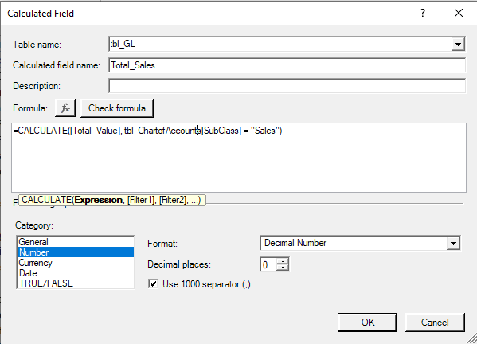 | Subclass = Sales | Quarter, Year, and Country
Gross_Profit | =CALCULATE([Total_Value], tbl_ChartofAccounts[Class] = "Trading account") | 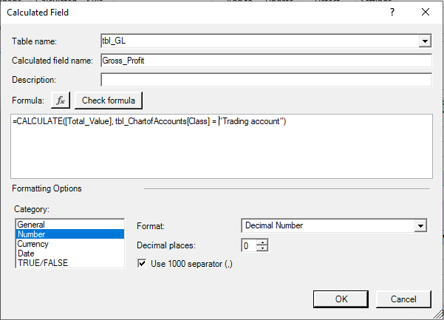 | Class = Trading Account | Quarter, Year, and Country
EBITDA | =[Gross_Profit] + CALCULATE([Total_Value], tbl_ChartofAccounts[SubClass] = "Operating Expenses") | 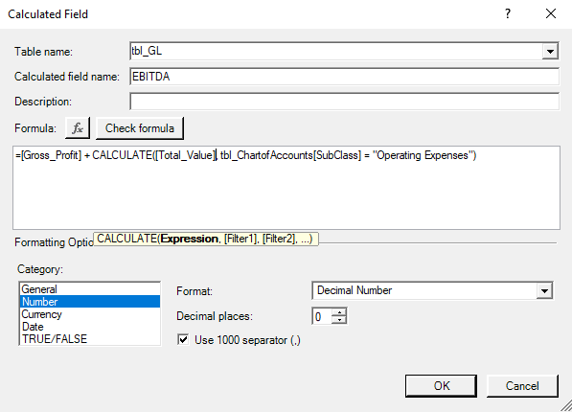 | Subclass = Sales, Cost of Sales, Operating Expenses | Quarter, Year, and Country
OperatingProfit | =[EBITDA]+CALCULATE([Total_Value], tbl_ChartofAccounts[SubClass] = "Depreciation & Amortization") | 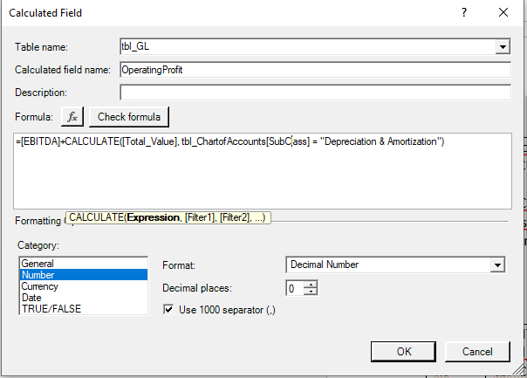 | Class = Trading Account, Operating Account | Quarter, Year, and Country
PBIT | =[OperatingProfit]+CALCULATE([Total_Value], tbl_ChartofAccounts[Class] = "Non-operating") | 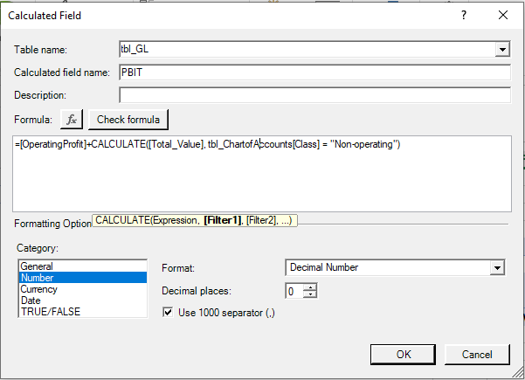 | Class = Trading Account, Operating Account, Non-operating Account | Quarter, Year, and Country
Net Profit | =[PBIT]+CALCULATE([Total_Value], tbl_ChartofAccounts[Class]= "Interest & Tax") | 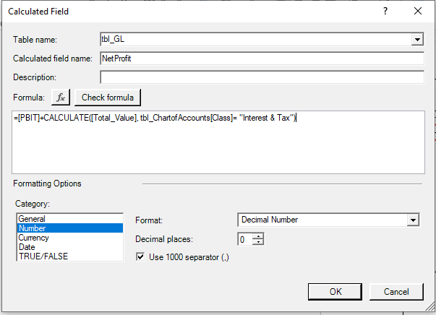 | Report = Profit & Loss | Quarter, Year, and Country
GrossProfitMargin | =[Gross_Profit] / [Total_Sales] | 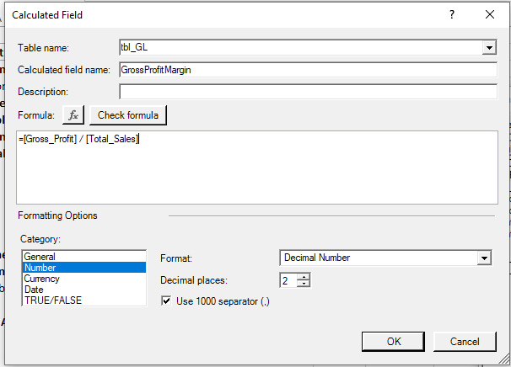
OperatingProfitMargin | =[OperatingProfit] / [Total_Sales] | 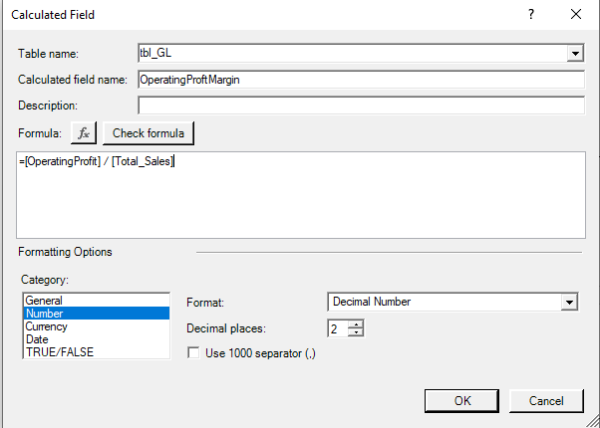
NetProfitMargin | =[NetProfit] / [Total_Sales] | 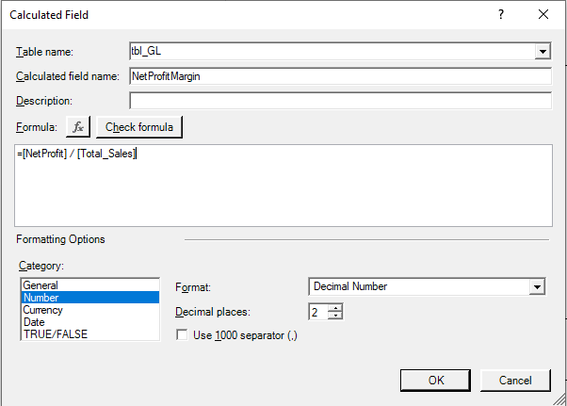

Findings
Can find and compare Total Sales, Gross Profit, EBITDA, Operating Profit, PBIT, and Net Profit for three financial years for 7 countries.

Tools Used
- Power Pivot (data modeling and DAX measures), Slicers

Data Source
- Publicly available (the primary data set)
Note: Only the P&L (DAX) Statement sheet is created. Other sheets are sourced.

